CSA15 – CLOUD COMPUTING AND BIG DATA ANALYTICS
ASSIGNMENT 1 – CO1 : ANSWER SHEET
Design, Analyse and Validate a Cloud-Based Solution for Migrating a Legacy University Management System
CO1: Apply cloud computing technologies including hardware–software evolution, virtualization, web services, and service models to develop cloud-based solutions.
Student Name | K N RITHEESH | Register Number | 192572097
Department / Section | CSE-AI | Academic Year / Semester | 2025
Faculty Name | Dr R LATHA | Nature of Assignment | Individual
Duration | 1 Week | Total Marks | 50
Submission Date | 31/10/26 | Evaluation Date

INDEX AND MARK SHEET (for evaluator)
Task | Title | Max | Awarded | Bloom's level
1 | Introduce Cloud Computing and Map It to the Scenario | 3 |  | L2
2 | Trace the Evolution and Hardware Evolution | 3 |  | L2
3 | Analyse Internet Software Evolution | 3 |  | L2
4 | Apply Server Virtualization | 5 |  | L3
5 | Apply Web Services | 4 |  | L3
6 | Analyse the Service Models: IaaS, PaaS and SaaS | 5 |  | L4
7 | Examine XaaS | 3 |  | L4
8 | Design the Cloud Solution Architecture | 5 |  | L6
9 | Hands-on Implementation and Documentation | 4 |  | L3
10 | Evaluate and Recommend the Final Solution | 7 |  | L5
11 | Re-evaluate and Adapt the Design (Day-4 Challenge) | 8 |  | L4/L5/L6
 | TOTAL | 50

How to read this answer sheet
- Every task starts with a small evaluator quick-check table that points to the section where each requirement is answered.
- All figures and tables are numbered and captioned (figures below, tables above). All diagrams were drawn for this assignment.
- All money values are illustrative estimates in Indian Rupees (Rs.), in lakh (1 lakh = 100,000), based on the assumptions stated in Task 10.
- Task 9: the code and the test log are real; the screenshot boxes must be filled with your own screenshots before submission.

SCENARIO SUMMARY AND ASSUMPTIONS
The university runs the Student Information System (SIS), Learning Management System (LMS), Library System, Exam Portal and E-mail on 12 ageing physical servers in one on-premise data centre, across 4 campuses with about 25,000 students and 2,000 staff. The key facts used throughout this answer sheet are summarised below.
Table 1: Key facts and working assumptions
Item | Value / assumption
Physical servers | 12 (one dedicated server per application component)
Average CPU utilisation | About 15 %; peaks above 95 % in admissions, result and exam weeks
Users | 25,000 students + 2,000 staff = 27,000 users on 4 campuses
Application style | Large monolithic programs, no public APIs, no mobile access, no partner access
Procurement / DR | 6–8 weeks per server; no disaster-recovery site
Assumed server split (to be used in Task 4) | SIS 3, LMS 3, Exam Portal 2, E-mail 2, Library 1, Directory/DNS/backup 1 = 12
Peak behaviour assumed | At any one peak, SIS, LMS and Exam Portal (8 of the 12 servers) run at 95 %; the other 4 stay near 15 %
Currency | Rs. lakh (illustrative); 3-year planning horizon

TASK 1 – Introduce Cloud Computing and Map It to the Scenario
Marks: 3
Table 2: Evaluator quick-check (requirement → section)
Task requirement | Answered in section
Definition and five essential characteristics | Section 1.1
Deployment models and best fit | Section 1.2
Three problems mapped to characteristics | Section 1.3
Benefits and limitations | Section 1.4

1.1 Definition and the five essential characteristics
Cloud computing is a model in which computing resources such as servers, storage, networks, platforms and applications are delivered as services over the network from a shared pool. Resources can be provisioned and released quickly, with very little management effort, and the user pays only for what is used.
Table 3: Five essential characteristics and their meaning for the university
Characteristic | Meaning | University example
On-demand self-service | Users create resources themselves, any time, without calling the provider. | IT team starts a new virtual server for admissions in minutes instead of waiting 6–8 weeks.
Broad network access | Services are reached over the network from many device types. | Students use the mobile app; partner colleges call the APIs; staff work from home.
Resource pooling | The provider serves many customers from one shared pool (multi-tenancy). | Idle capacity is shared, so the university stops paying for 12 mostly idle servers.
Rapid elasticity | Capacity expands and shrinks quickly, often automatically. | More servers during result publication, fewer during vacations.
Measured service | Usage is metered, monitored and billed. | Each campus or college can be charged for what it consumes.

1.2 Deployment models and the model that suits the university
Table 4: Comparison of deployment models
Model | Description | Fit for the university | Verdict
Public | Owned by a provider and shared by many customers over the Internet. | Best for elastic, peak-heavy web and API tiers; lowest cost. | Use for web/API tier, LMS, e-mail
Private | Used by one organisation (on-site or hosted). | Good for sensitive student data and exam question banks; limited elasticity. | Use for sensitive data
Hybrid | A combination of private and public clouds connected securely. | Keeps sensitive data under control while using public cloud for peaks and DR. | Recommended
Community | Shared by organisations with common needs. | Suitable later for the 40 affiliated colleges (shared student-record services). | Future option

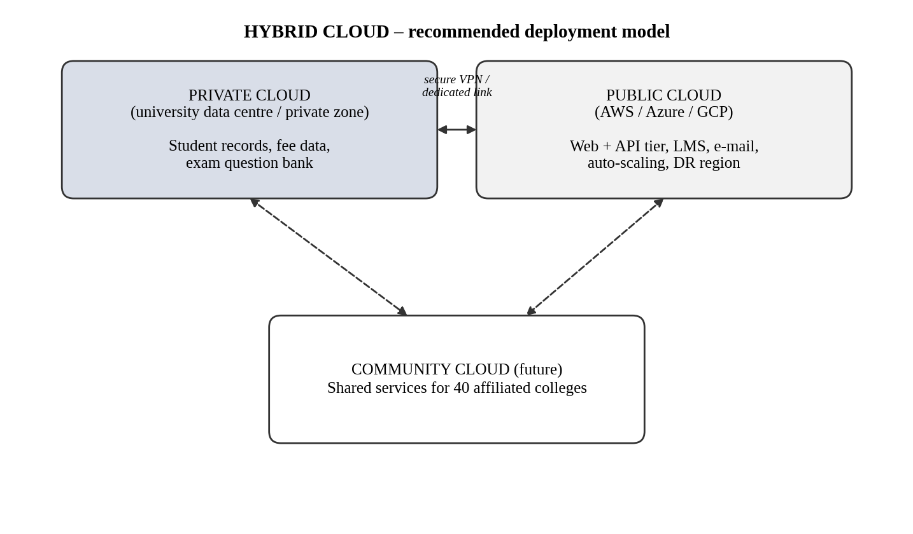
Figure 1: Hybrid cloud deployment model proposed for the university
Decision: A hybrid cloud suits the university best. Student records and exam data stay in a controlled private zone, while the public cloud supplies elastic capacity during admissions and exams and a disaster-recovery region that the university does not have today.

1.3 Three problems of the current setup and how cloud characteristics address them
Table 5: Problem-to-characteristic mapping
Problem in the on-premise setup | Cloud characteristic | How it is solved
1. Servers are idle (about 15 % utilisation) but still cost money for hardware, power and space. | Resource pooling + measured service | Workloads share pooled capacity, and the university pays only for resources actually used.
2. Systems fail under peak load (above 95 % in admissions and exams). | Rapid elasticity | Auto-scaling adds capacity when load rises and removes it afterwards, so peaks do not crash the system.
3. Buying a server takes 6–8 weeks and needs large capital spending. | On-demand self-service | Resources are created in minutes and paid as operating expenditure.
Extra: no mobile or partner access, and no disaster recovery. | Broad network access (and pooling across regions) | APIs are exposed securely over the Internet, and data is replicated to a second region.

1.4 Benefits and limitations of cloud adoption
Table 6: Benefits and limitations for the university
Benefits | Limitations
Lower upfront cost (CapEx becomes OpEx) | Recurring monthly bills can grow if not monitored
Handles peaks through elasticity | Dependence on Internet connectivity and the provider
Built-in backup and disaster recovery options | Vendor lock-in and data-privacy/legal concerns
Faster delivery of new services (mobile app, APIs) | Staff need new cloud and DevOps skills
Less hardware maintenance effort | Migration of old monolithic applications takes time and effort

TASK 2 – Trace the Evolution and Hardware Evolution
Marks: 3
Table 7: Evaluator quick-check (requirement → section)
Task requirement | Answered in section
Timeline from mainframe to cloud | Section 2.1
Hardware evolution | Section 2.3
How each stage solved the previous limitation | Section 2.2
Stage matching the university's system | Section 2.4

2.1 Timeline of computing evolution
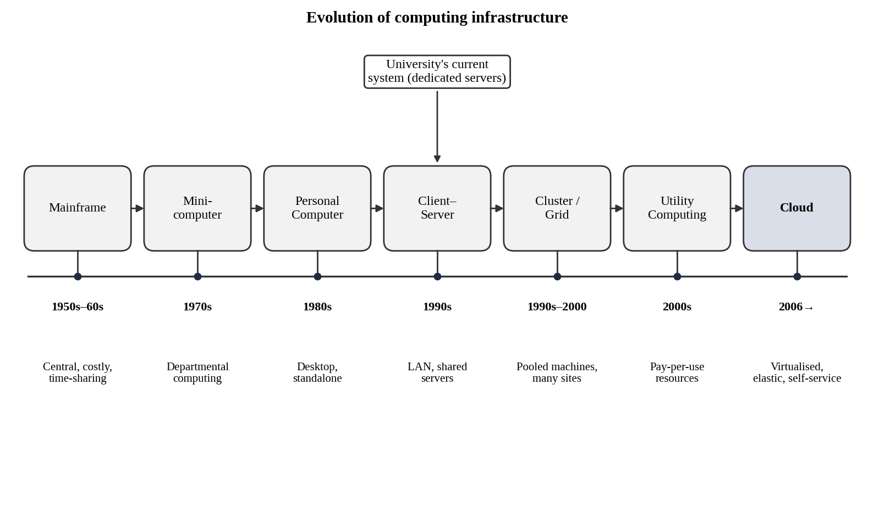
Figure 2: Timeline: mainframes to cloud computing, with the university's current position

2.2 How each stage solved a limitation of the previous one
Table 8: Stage-wise evolution
Stage | Key idea | Limitation solved | Limitation left behind
Mainframe | One large central computer; users share it using terminals (time-sharing). | Computing became possible for many users on one machine. | Very expensive, central, hard to scale.
Minicomputer | Smaller, cheaper machines for departments. | Cost and access of mainframes. | Islands of computing, limited power.
Personal computer | Individual desktop machines with local software. | Personal access and low cost. | Data and software scattered; hard to share.
Client–server | Clients request services from shared servers over a LAN. | Sharing of data and applications. | One application per server; poor utilisation; manual scaling.
Cluster computing | Many machines act as one system. | Single-server performance and reliability limits. | Usually within one site and one organisation.
Grid computing | Resources from different sites combined for large tasks. | Limited capacity of one cluster. | Complex to use; no simple billing.
Utility computing | Computing sold like electricity: pay per use. | Large upfront investment. | Early platforms lacked automation and flexibility.
Cloud computing | Virtualised, elastic, self-service resources through the Internet. | Wasted capacity, slow provisioning, capital cost. | Network dependence, lock-in, security responsibility.

2.3 Hardware evolution that enabled the cloud
Table 9: Hardware advances and their role
Hardware advance | What changed | Why it matters for the cloud
Multi-core processors | Many CPU cores on one chip, with hardware virtualization support. | Many virtual machines can run on one server.
Commodity servers | Low-cost standard x86 servers replaced special hardware. | Providers build huge pools cheaply and replace failures easily.
High-capacity storage | Cheap disks, SSDs and distributed storage. | Large, durable object and database storage at low cost.
High-speed networking | Gigabit to 100-Gbps links and broadband Internet. | Services can be used remotely with low delay.
Data centres | Large facilities with shared power, cooling and automation. | Economies of scale and multi-region resilience.

2.4 Which stage does the university's current system correspond to?
The university's system corresponds to the client–server stage (1990s style), run in a single in-house data centre. The reasons are:
- One application, one dedicated server: no resource pooling, hence the 15 % average utilisation.
- Manual, slow scaling: servers take 6–8 weeks to buy, so there is no elasticity.
- Monolithic programs with no public interfaces: they were built for LAN clients, not for mobile or partner access.
- No DR site and fixed capital cost: typical of owned infrastructure, not of utility or cloud computing.

TASK 3 – Analyse Internet Software Evolution
Marks: 3
Table 10: Evaluator quick-check (requirement → section)
Task requirement | Answered in section
Evolution from static web to cloud-hosted applications | Section 3.1
Role of browsers, HTTP, AJAX and APIs | Section 3.2
Desktop vs client–server vs web-delivered | Section 3.3
Effect on the university's application design | Section 3.4

3.1 Evolution of internet software
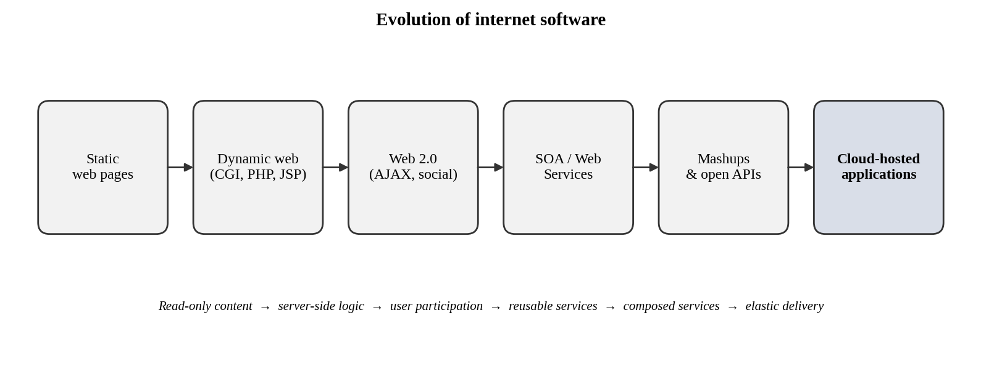
Figure 3: Evolution of internet software from static pages to cloud-hosted applications
Table 11: Stages of internet software evolution
Stage | Description | University relevance
Static web pages | Fixed HTML pages, read-only. | Notice board, syllabus pages.
Dynamic web | Server-side programs (CGI, PHP, JSP) create pages from a database. | Result lookup, online forms.
Web 2.0 | Interactive, user-generated content; AJAX updates parts of a page. | Discussion forums, live attendance dashboards.
SOA / web services | Functions exposed as reusable services with standard interfaces. | Fee, result and library functions become services.
Mashups | Combining several services or APIs into a new application. | Mobile app that joins results, fees and timetable.
Cloud-hosted applications | Applications run on elastic, remotely managed infrastructure. | SIS, exam portal and LMS delivered through the browser.

3.2 Role of browsers, HTTP, AJAX and APIs
Table 12: Enabling technologies
Technology | Role in delivering software over the Internet
Browser | Universal client: runs the user interface, so nothing is installed on the user's computer.
HTTP / HTTPS | Standard request–response protocol; HTTPS adds encryption. Works through firewalls and across any network.
AJAX | Lets a page request data in the background and update only part of the screen, giving desktop-like responsiveness.
APIs | Defined interfaces (usually REST/JSON) that let programs, mobile apps and partner systems use the application's functions.

3.3 Desktop, client–server and web-delivered software
Table 13: Comparison of software delivery models
Aspect | Desktop software | Client–server software | Web-delivered software
Installation | On every computer | Client program on each PC | None; browser only
Updates | Manual, per machine | Server and clients updated | Updated once on the server
Access | Only that computer | Inside the LAN or VPN | Anywhere with Internet
Scalability | Not applicable | Add servers manually | Automatic and elastic
Integration | Poor | Limited, custom | Standard APIs
Maintenance cost | High (many devices) | Medium | Low and centralised

3.4 Effect on the design of the university's applications
- Browser/mobile front end replaces client installations, so no software is installed in labs or on staff PCs.
- API-first design: every function (results, fees, library search) gets a REST API so that the mobile app and partner colleges can use it.
- Break the monolith into services (SIS, fees, exams, library) that can be scaled and updated independently.
- Stateless application tier (session data kept in cache or database) so that any server instance can serve any request, which makes auto-scaling possible.
- Security by design: HTTPS everywhere, authentication tokens and role-based access for students, staff and colleges.

TASK 4 – Apply Server Virtualization
Marks: 5
Table 14: Evaluator quick-check (requirement → section)
Task requirement | Answered in section
Hypervisor working, Type-1 vs Type-2 | Section 4.1
Four virtualization types compared | Section 4.2
VMs vs containers per application | Section 4.3
Consolidation calculation (with working) | Section 4.4
Live migration, snapshots, over-commit and risks | Section 4.5

4.1 How a hypervisor works; Type-1 and Type-2
A hypervisor (virtual machine monitor) is software that sits between the hardware and the virtual machines (VMs). It divides the physical CPU, memory, storage and network among several VMs, gives each VM its own virtual hardware, and isolates the VMs from each other. Each VM runs its own guest operating system and application as if it were on a separate computer.
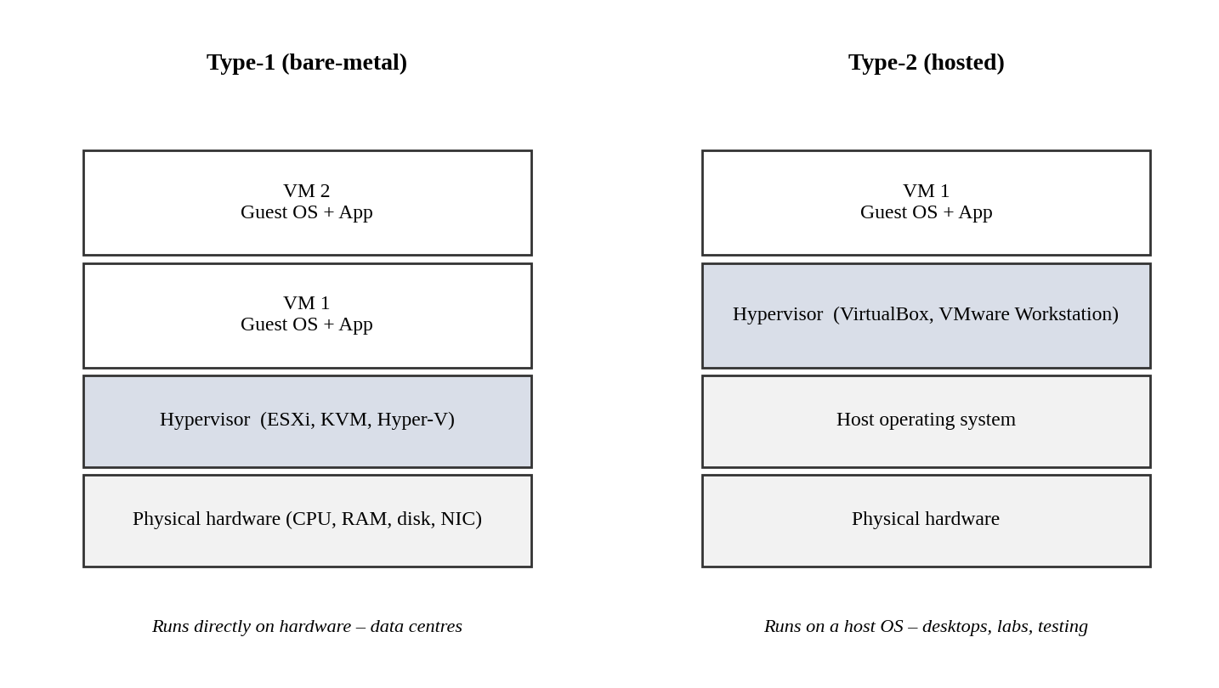
Figure 4: Type-1 (bare-metal) and Type-2 (hosted) hypervisor architectures
Table 15: Type-1 vs Type-2 hypervisors
Aspect | Type-1 (bare-metal) | Type-2 (hosted)
Runs on | Directly on hardware | On top of a host operating system
Performance | High, small overhead | Lower, host OS adds overhead
Typical use | Production data centres and clouds | Desktops, labs, development and testing
Examples | VMware ESXi, Microsoft Hyper-V, KVM, Xen | Oracle VirtualBox, VMware Workstation
University use | Production hosts for SIS, LMS, Exam Portal | Student labs and the Task 9 proof-of-concept

4.2 Comparison of virtualization techniques
Table 16: Full, para-, OS-level and hardware-assisted virtualization
Technique | How it works | Advantages | Limitations
Full virtualization | Hypervisor emulates complete hardware; unmodified guest OS runs. | Any OS can run; strong isolation. | Some overhead from emulation (without hardware help).
Para-virtualization | Guest OS is modified to call the hypervisor directly (hypercalls). | Better performance than pure emulation. | Needs modified guest OS; less portable.
OS-level (containers) | Containers share the host kernel; each has isolated processes and file system. | Very light, start in seconds, high density. | Same kernel for all; weaker isolation than VMs.
Hardware-assisted | CPU features (Intel VT-x, AMD-V) support virtualization directly. | Near-native speed; makes full virtualization efficient. | Needs supporting CPUs (now standard).

4.3 Which applications should run as VMs and which as containers
Table 17: Placement plan
Component | Choice | Reason
SIS database | VM (or DBaaS) | Stateful, critical data; needs strong isolation and snapshots.
SIS web/application tier | Containers | Stateless and scalable; many identical copies can be started quickly in admissions.
LMS application | Containers | Web tier scales with the number of students online; easy updates.
Exam Portal | Containers (+ VM for proctoring service) | Needs very fast scale-out during exams; the proctoring tool needs a full OS, so it stays in a VM.
Library system | VM | Small, stable legacy application with low load; lift-and-shift with no code change.
Directory, DNS, backup | VM | Infrastructure services that need OS-level control.
E-mail | Moved to SaaS | Commodity service; provider runs it (see Task 6).

4.4 Consolidation calculation
Assumptions: (i) the new virtualization hosts have the same capacity as one old server (a conservative assumption, because new hardware is usually faster); (ii) the current average utilisation is 15 % on each of the 12 servers; (iii) the target host utilisation is 70 %, leaving 30 % headroom for spikes and for the hypervisor itself.
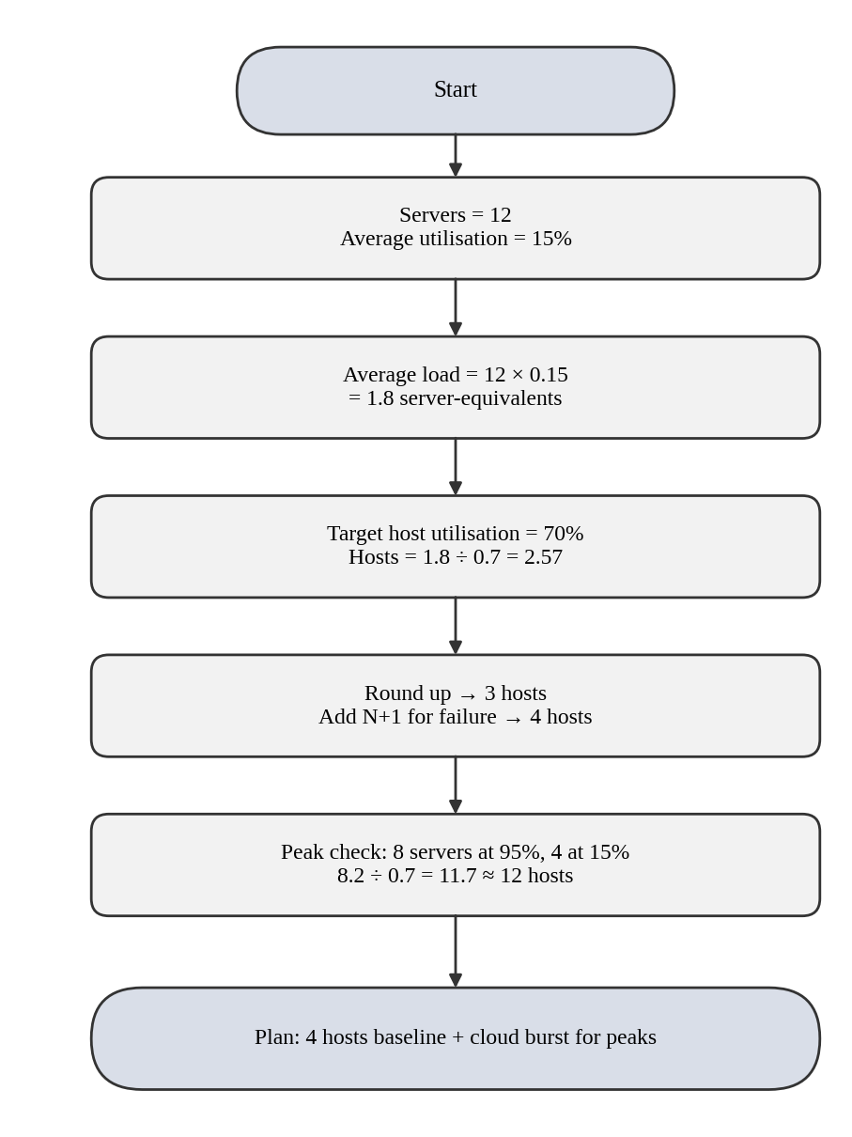
Figure 5: Flowchart of the server consolidation calculation

Step-by-step working
- Total average load = number of servers × average utilisation = 12 × 0.15 = 1.8 server-equivalents.
- Hosts needed at the target utilisation = 1.8 ÷ 0.70 = 2.57 ≈ 3 hosts (rounded up).
- High availability (N+1): if one host fails, the rest must still carry the load, so add 1 host → 4 hosts.
- Peak-load check: assume SIS, LMS and Exam Portal (8 of 12 servers) run at 95 % at the same time and the other four stay at 15 %. Load = (8 × 0.95) + (4 × 0.15) = 7.6 + 0.6 = 8.2 server-equivalents; hosts needed = 8.2 ÷ 0.70 = 11.7 ≈ 12 hosts.
- A 12-host plan would remove all savings. Therefore, only 4 hosts are kept as a baseline and the extra peak capacity is rented from the cloud (cloud bursting / auto-scaling) only during admissions, results and exams.
Result: 12 physical servers can be consolidated into 3 hosts for average load, 4 hosts with N+1 redundancy. That is a reduction of 66.7 % (12 → 4 hosts). Peak demand must be handled by elasticity, not by owning hardware. These figures should be validated by load testing before purchase.

4.5 Benefits and risks of virtualization
Table 18: Benefits and risks
Item | Explanation | Relevance / control
Live migration (benefit) | A running VM moves to another host without downtime. | Allows host maintenance during working hours.
Snapshots (benefit) | A saved point-in-time state of a VM. | Quick rollback after a failed upgrade or exam-day error.
Over-commitment (benefit) | More virtual CPUs/memory are allocated than physically exist, because VMs rarely peak together. | Example: 32-core host with a 3:1 vCPU ratio offers 96 vCPUs. Raises density, but must be monitored.
Noisy neighbour (risk) | One busy VM takes shared resources from others. | Use CPU/memory limits, reservations and resource pools.
Hypervisor failure (risk) | A failed host stops all VMs on it. | Cluster hosts with automatic restart (HA) and N+1 capacity.
Security isolation (risk) | A hypervisor or VM-escape weakness could expose other VMs. | Patch regularly, separate sensitive VMs, use network segmentation.

TASK 5 – Apply Web Services
Marks: 4
Table 19: Evaluator quick-check (requirement → section)
Task requirement | Answered in section
Overview of web services in SOA and cloud | Section 5.1
SOAP, WSDL, UDDI and REST compared | Section 5.2
Three university web services with request/response | Section 5.3
SOAP or REST justification | Section 5.4

5.1 Overview of web services
A web service is a software function that is made available over a network using standard protocols, so that different programs, written in different languages and running on different platforms, can use it. In Service-Oriented Architecture (SOA) an application is built from such loosely coupled services. In the cloud, web services are the way in which mobile apps, partner colleges and other cloud services use the university's functions.
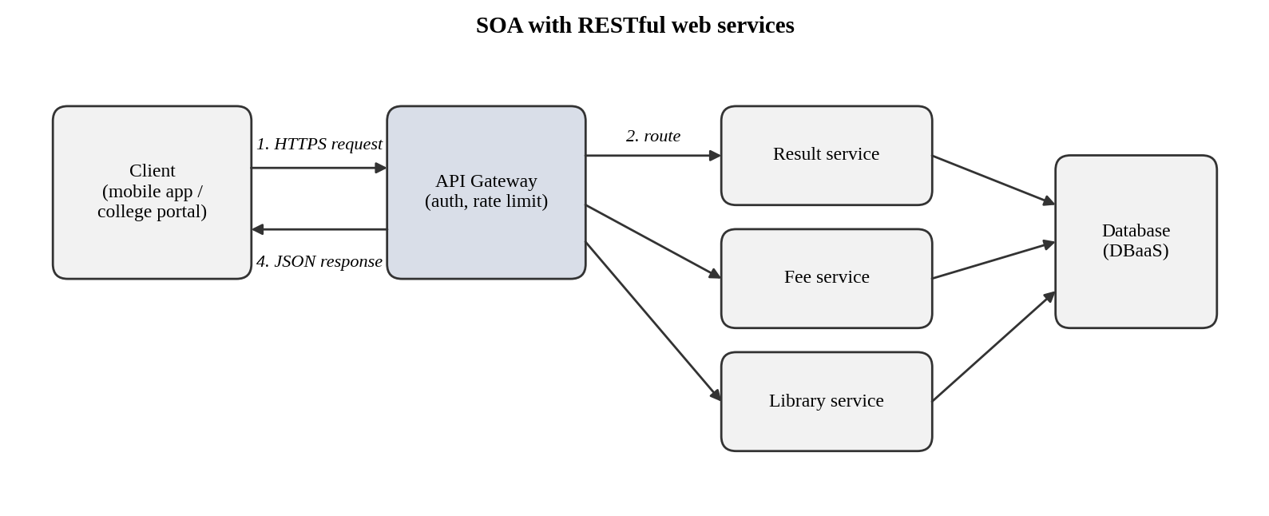
Figure 6: SOA for the university: clients reach services through an API gateway

5.2 SOAP, WSDL, UDDI and REST
Table 20: Comparison of web-service technologies
Item | What it is | Key points
SOAP | An XML-based messaging protocol with a strict envelope format. | Usually POST over HTTP; supports WS-Security and transactions; heavy XML messages.
WSDL | XML document that describes a SOAP service: operations, messages and endpoints. | Machine-readable contract that tools use to generate client code.
UDDI | A registry where services are published and discovered. | Rarely used today; replaced by API catalogues and gateways.
REST | An architectural style that uses URLs for resources and HTTP methods for actions. | GET, POST, PUT, DELETE; lightweight JSON (or XML); stateless; cacheable; easy for mobile.

5.3 University functions exposed as web services

Service 1 – Result lookup
Endpoint: /api/v1/students/{regno}/results Method: GET
Request:
GET /api/v1/students/REG1001/results?semester=5
Authorization: Bearer <token>

Response: 200 OK
{ "regno": "REG1001", "name": "Arun Kumar", "semester": 5,
"cgpa": 8.42, "subjects": { "CSA15": "A", "CSA12": "B+" } }

Error: 404 Not Found
{ "error": "Student not found", "regno": "REG9999" }

Service 2 – Fee payment
Endpoint: /api/v1/payments Method: POST (creates a payment)
Request:
POST /api/v1/payments
Authorization: Bearer <token>
Idempotency-Key: 7d1c-93ab
Content-Type: application/json
{ "regno": "REG1001", "amount": 45000, "term": "2026-ODD" }

Response: 201 Created
{ "status": "SUCCESS", "txnId": "TXN20261031001",
"regno": "REG1001", "amount": 45000 }

Error: 400 Bad Request
{ "error": "regno and amount are required" }

Service 3 – Library search
Endpoint: /api/v1/library/books Method: GET
Request:
GET /api/v1/library/books?title=cloud+computing&available=true

Response: 200 OK
{ "count": 2, "books": [
{ "id": "B101", "title": "Cloud Computing Basics", "copies": 3 },
{ "id": "B245", "title": "Cloud Architecture", "copies": 1 } ] }

5.4 SOAP or REST for each function
Table 21: Choice and justification
Function | Choice | Justification
Result lookup | REST | Read-only, high volume, cacheable with GET; JSON is light for mobile; no complex transaction rules.
Fee payment | REST (SOAP only as an adapter) | The mobile app needs a simple, fast interface; security comes from HTTPS, OAuth 2.0 tokens and an idempotency key. SOAP with WS-Security is used only if a partner bank's gateway insists on it, behind an adapter.
Library search | REST | Simple search queries with filters; responses are cacheable; used by mobile and partner libraries.

TASK 6 – Analyse the Service Models: IaaS, PaaS and SaaS
Marks: 5
Table 22: Evaluator quick-check (requirement → section)
Task requirement | Answered in section
Definitions and layer-wise responsibility | Section 6.1
Five applications categorised with reasons | Section 6.2
Comparison of models | Section 6.3
One provider example per model | Section 6.2 and 6.3

6.1 Definitions and who manages which layer
- IaaS (Infrastructure as a Service): the provider supplies virtual machines, storage and networks; the customer installs and manages the operating system, middleware and applications.
- PaaS (Platform as a Service): the provider also manages the operating system and runtime; the customer deploys application code and data.
- SaaS (Software as a Service): the provider delivers a complete application; the customer only configures and uses it.
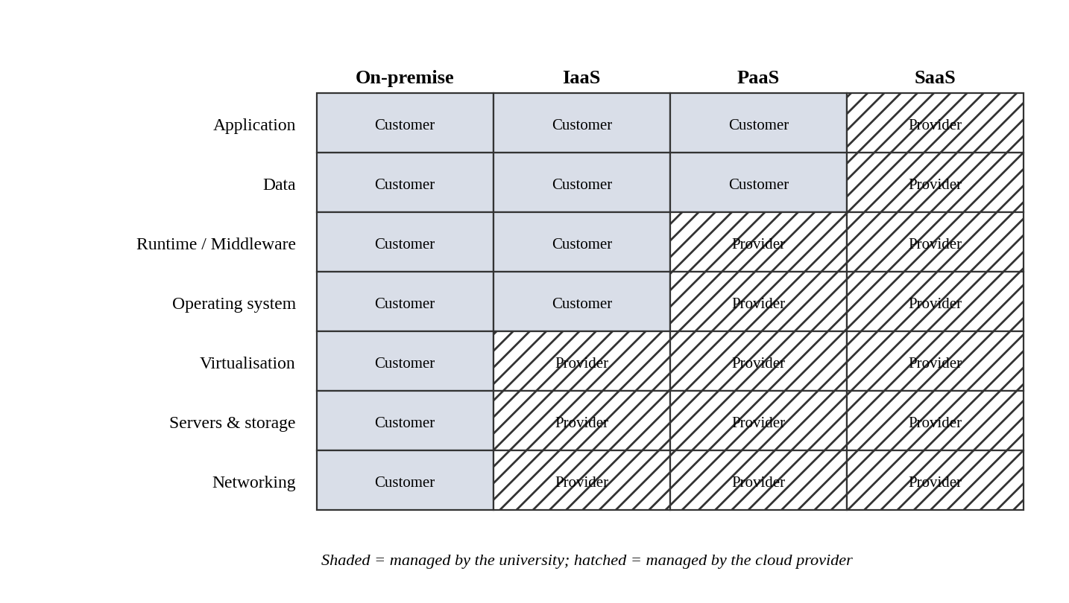
Figure 7: Responsibility layers in on-premise, IaaS, PaaS and SaaS
Table 23: Layer-wise responsibility
Layer | On-premise | IaaS | PaaS | SaaS
Application | Customer | Customer | Customer | Provider
Data | Customer | Customer | Customer | Provider*
Runtime / middleware | Customer | Customer | Provider | Provider
Operating system | Customer | Customer | Provider | Provider
Virtualisation | Customer | Provider | Provider | Provider
Servers, storage, network | Customer | Provider | Provider | Provider

*In SaaS the customer remains legally responsible for its data (access, retention and privacy), even though the provider runs the system.

6.2 Categorisation of the five applications
Table 24: Application-to-service-model mapping
Application | Model | Reason (summary) | Example provider
Student Information System (SIS) | PaaS | Custom code and sensitive data stay under university control, while the provider handles servers, OS, scaling and patches. | Azure App Service / Google App Engine + managed database
Learning Management System (LMS) | SaaS | Commodity function; hosted Moodle or Google Classroom removes server work. | Google Workspace for Education / hosted Moodle
Library system | SaaS | Small, standard function; subscription cloud library software is cheaper than running a server. | Cloud library SaaS (hosted Koha)
Exam Portal | IaaS | Needs OS-level control for proctoring tools and exam-security settings, and a very spiky load that VM auto-scaling can handle. | AWS EC2 with Auto Scaling
E-mail | SaaS | Standard service; provider offers spam filtering, storage and high availability. | Microsoft 365 / Google Workspace

Reasoning behind each decision
SIS → PaaS. The SIS is custom software that must expose APIs and survive admissions peaks. With PaaS, the team keeps control of code and data, but the provider removes the work of patching operating systems and scaling servers. IaaS would keep that work with the university, while SaaS would not fit the university's own rules (marks, fee structure). The monolith first runs on VMs and is gradually refactored into the PaaS (see roadmap).
LMS → SaaS. Teaching and learning tools are standard across universities. Moving to SaaS gives automatic scaling for online classes and removes maintenance. The trade-off is less customisation and some vendor lock-in.
Library → SaaS. The library system has low and steady load and no special customisation needs. A subscription service removes the need for a dedicated server and database administrator.
Exam Portal → IaaS. Exams need controlled environments (secure browsers, proctoring services, fixed time slots). Full control of VMs allows these settings, and scheduled auto-scaling groups give capacity for the exam week. Later, the web tier can be containerised.
E-mail → SaaS. E-mail is the most standard service and the easiest to migrate. SaaS gives high availability, security filtering and storage without any server.

6.3 Comparison of the models
Table 25: IaaS vs PaaS vs SaaS
Criterion | IaaS | PaaS | SaaS
Control | Highest (OS and above) | Medium (code and data) | Lowest (configuration only)
Cost | Pay for VMs; more admin cost | Pay per app/usage; lower admin cost | Per-user subscription; no infra cost
Scalability | Good, but you configure it | Very good, mostly automatic | Automatic, by provider
Maintenance effort | High | Medium | Very low
Vendor lock-in | Low–medium (VM images portable) | Medium–high (platform services) | High (data and features tied to vendor)
Provider example | AWS EC2 | Google App Engine / Azure App Service | Google Workspace / Microsoft 365

TASK 7 – Examine XaaS
Marks: 3
Table 26: Evaluator quick-check (requirement → section)
Task requirement | Answered in section
XaaS explained; at least four variants | Section 7.1
Two offerings selected and justified | Section 7.2
Risks of over-reliance | Section 7.3

7.1 What is XaaS and its variants
XaaS (Anything-as-a-Service) is the general idea that almost any IT function can be delivered as a service over the network and billed by use. It extends IaaS, PaaS and SaaS to more specialised services.
Table 27: Six XaaS variants
Variant | What it provides | Possible university use
DaaS (Desktop as a Service) | Virtual desktops delivered from the cloud. | Lab computers for students on any device.
MBaaS (Mobile Backend as a Service) | Ready backend (login, push messages, storage) for mobile apps. | Backend for the new student mobile app.
FaaS (Function as a Service) | Run small functions on events; pay per execution (serverless). | Result notification and PDF receipt generation.
DBaaS (Database as a Service) | Managed database with backup, patching and replication. | Student records and fee database.
SECaaS (Security as a Service) | Cloud-delivered security (firewall, identity, threat monitoring). | Identity and web-attack protection.
DRaaS (Disaster Recovery as a Service) | Replication and recovery of systems in a second site. | Fast restore if the main site fails.

7.2 Two XaaS offerings selected for the university
1. DBaaS. Student, fee and exam data is the most valuable and most sensitive asset. DBaaS gives automatic backups, patching, high availability across zones and easy scaling, so a small IT team does not need full-time database administrators. It also supports the fee-payment and results APIs under heavy load.
2. DRaaS. The university currently has no disaster-recovery site, and building one would be costly. DRaaS provides replication to another region on a pay-per-use basis, with targets such as an RPO of 15 minutes and an RTO of 1 hour. It directly supports the 99.9 % availability demand of Task 11.

7.3 Risks of over-reliance on many 'as-a-Service' providers
Table 28: Risks and mitigation
Risk | Explanation | Mitigation
Vendor lock-in | Proprietary services make switching costly. | Use open standards (SQL, containers, REST); keep exportable backups.
Multiple points of failure | An outage at any one provider can break the whole chain. | Define SLAs; design graceful degradation and fallback.
Integration complexity | Many services need many connections and accounts. | Use an API gateway and central identity (SSO).
Data privacy and compliance | Data spreads across providers and locations. | Choose Indian regions, sign data-processing agreements, encrypt data.
Cost sprawl | Many small subscriptions add up. | Tagging, budgets and monthly cost reviews.

TASK 8 – Design the Cloud Solution Architecture
Marks: 5
Table 29: Evaluator quick-check (requirement → section)
Task requirement | Answered in section
Architecture diagram with all required parts | Section 8.1
Deployment and service model per component | Section 8.2
Elasticity handling for peaks | Section 8.3
Security and availability measures | Section 8.4

8.1 Architecture diagram
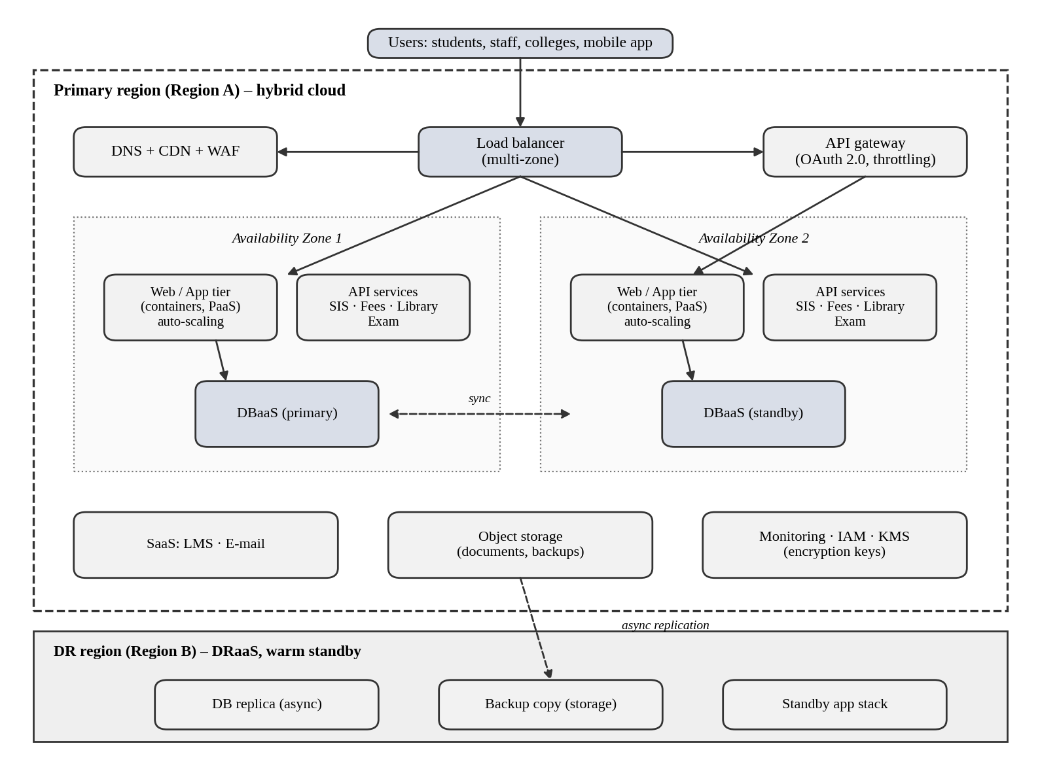
Figure 8: Proposed hybrid cloud architecture with multi-zone deployment and DR region
How the design works: users reach the system through DNS, CDN and a web application firewall. A multi-zone load balancer spreads requests to the web/app tier in two availability zones. The API layer (behind the API gateway) exposes SIS, fee, library and exam functions. Data is stored in a managed database with a standby in the second zone, and documents and backups are kept in object storage that is replicated to the DR region.

8.2 Deployment model and service model per component
Table 30: Component-wise justification
Component | Deployment | Service model | Justification
DNS, CDN, WAF | Public | SaaS/XaaS | Absorbs traffic, caches static content and blocks common web attacks.
Load balancer | Public | IaaS service | Spreads traffic across zones and removes unhealthy servers.
Web/app tier | Public (hybrid) | PaaS / containers | Stateless and auto-scaling for admissions and exams.
API gateway + services | Public | PaaS | Single secure entry point with authentication and rate limits.
Database | Private/public (hybrid) | DBaaS (XaaS) | Managed backup, patching and multi-zone failover for sensitive records.
Object storage | Public (encrypted) | IaaS | Durable, low-cost storage for documents and backups.
LMS and e-mail | Public | SaaS | No servers to run; elastic by design.
DR region | Public | DRaaS | Pay-per-use disaster recovery in a second region.
VPN to campus | Hybrid link | Network service | Safe connection from campuses and any retained on-site systems.

8.3 Elasticity (auto-scaling) for admissions and exam peaks
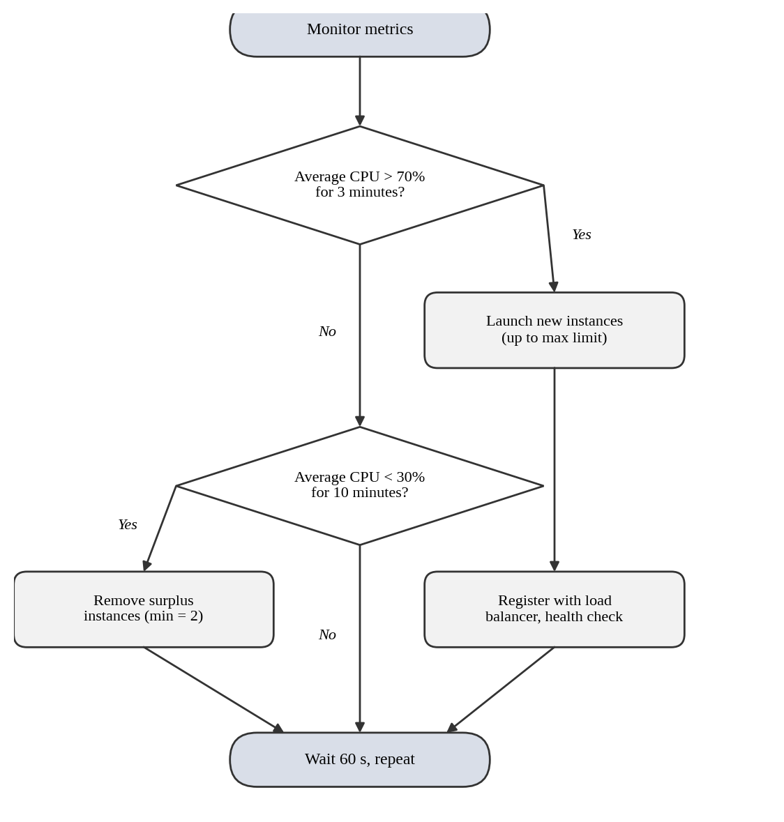
Figure 9: Flowchart of the auto-scaling decision
- Scheduled scaling: admissions, result days and exam weeks are known in advance, so capacity is raised beforehand (for example, from 2 to 10 instances) to avoid the delay of starting new servers.
- Metric-based scaling: if average CPU stays above 70 % for 3 minutes, new instances start; if below 30 % for 10 minutes, extra instances are removed, never going below 2 instances.
- Protection: a maximum instance limit and budget alerts prevent unlimited cost; queues and caching reduce database pressure.

8.4 Security and availability measures
Table 31: Security and availability controls
Area | Measure
Access control | Role-based access, multi-factor authentication for staff, least privilege, separate admin accounts.
Encryption | HTTPS/TLS for data in transit; AES-256 encryption for databases and storage; keys held in a key-management service.
Network security | Private subnets for database and app tiers, security groups, WAF and DDoS protection.
Backup | Daily full backups plus frequent log backups; copies stored in the DR region; restore tests every term.
Multi-zone deployment | Two availability zones for app and database; automatic failover; health checks.
Disaster recovery | Warm standby in region B; target RPO 15 min, RTO 1 hour.
Monitoring | Central logs, alerts for CPU, errors and cost; audit trail of administrator actions.

TASK 9 – Hands-on Implementation and Documentation
Marks: 4
Table 32: Evaluator quick-check (requirement → section)
Task requirement | Answered in section
Container hosting a REST API for one function | Section 9.2–9.3
PaaS / SaaS component deployed | Section 9.4
Testing with a client and recorded output | Section 9.5
Screenshots, steps and issues | Section 9.6, 9.7

Important for honest evaluation: the source code and the test log below were actually run (Python/Flask, local test client). Docker build, cloud deployment and screenshots depend on your own computer and cloud account, so run the commands and paste your own screenshots into the boxes in section 9.6 before you submit.

9.1 Environment and tools
Table 33: Environment
Item | Details
Function implemented | Result lookup REST API (plus health check and fee-payment demo endpoint)
Language / framework | Python 3.12, Flask 3.1, Gunicorn (production server)
Virtualisation tool | Docker (container) – or VirtualBox Ubuntu VM as an alternative
PaaS / SaaS component | Free-tier PaaS web service (for example Azure App Service F1, Google Cloud Run or Render) with a managed database or static site
Test client | curl and Postman (or a browser for GET requests)

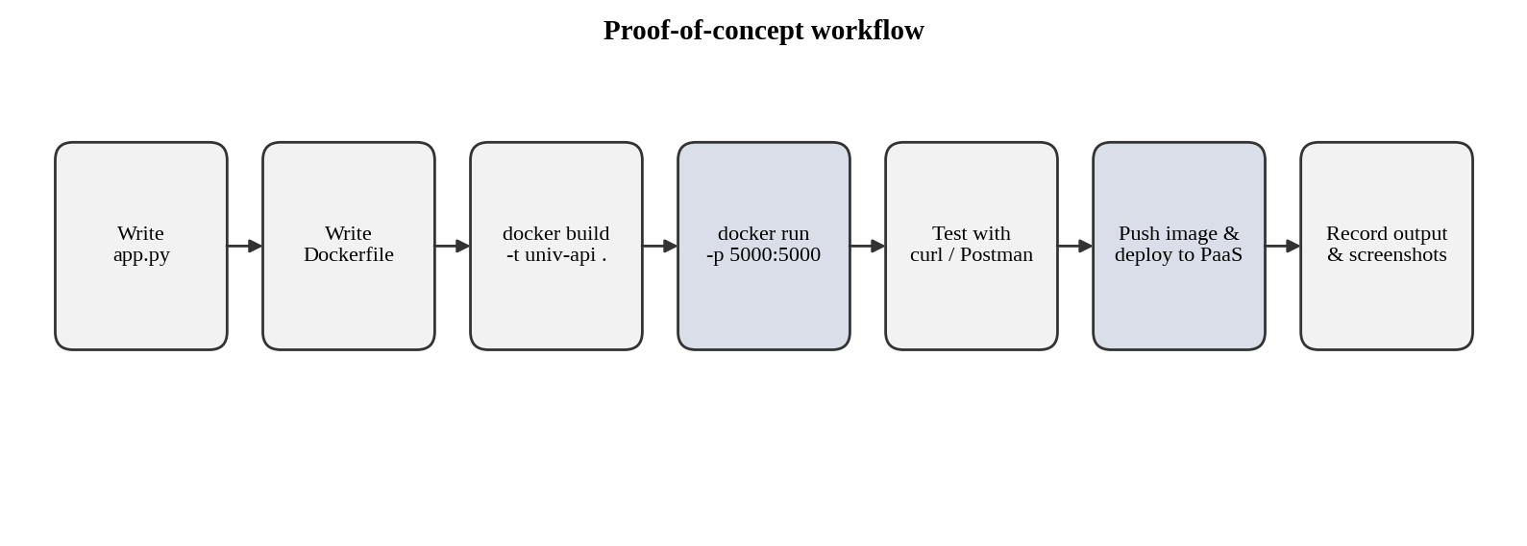
Figure 10: Proof-of-concept workflow

9.2 Source code

app.py
from flask import Flask, jsonify, request

app = Flask(__name__)

# Sample in-memory data (stands in for the managed database in the PoC)
RESULTS = {
"REG1001": {"name": "Arun Kumar", "semester": 5, "cgpa": 8.42,
"subjects": {"CSA15": "A", "CSA12": "B+", "CSA18": "A+"}},
"REG1002": {"name": "Meena S", "semester": 5, "cgpa": 9.10,
"subjects": {"CSA15": "O", "CSA12": "A", "CSA18": "A+"}},
}

@app.route("/health")
def health():
return jsonify(status="UP", service="university-result-api"), 200

@app.route("/api/v1/students/<regno>/results", methods=["GET"])
def get_result(regno):
record = RESULTS.get(regno.upper())
if record is None:
return jsonify(error="Student not found", regno=regno), 404
return jsonify(regno=regno.upper(), **record), 200

@app.route("/api/v1/payments", methods=["POST"])
def make_payment():
data = request.get_json(silent=True) or {}
if not data.get("regno") or not data.get("amount"):
return jsonify(error="regno and amount are required"), 400
return jsonify(status="SUCCESS", txnId="TXN20261031001",
regno=data["regno"], amount=data["amount"]), 201

if __name__ == "__main__":
app.run(host="0.0.0.0", port=5000)

requirements.txt
flask==3.1.3
gunicorn==23.0.0

Dockerfile
FROM python:3.12-slim
WORKDIR /app
COPY requirements.txt .
RUN pip install --no-cache-dir -r requirements.txt
COPY app.py .
EXPOSE 5000
CMD ["gunicorn", "-b", "0.0.0.0:5000", "app:app"]

9.3 Build and run the container
# 1. Build the image
docker build -t univ-result-api .

# 2. Run the container (map port 5000)
docker run -d --name univ-api -p 5000:5000 univ-result-api

# 3. Confirm it is running
docker ps
curl http://localhost:5000/health

9.4 PaaS / SaaS deployment steps
- Create a free-tier account on the chosen cloud (Azure, Google Cloud, AWS or Render).
- Push the code to a GitHub repository (or push the Docker image to a container registry).
- Create a new web service / app service and connect it to the repository or image. Set the start command to gunicorn -b 0.0.0.0:5000 app:app, or the port given by the platform.
- For the SaaS/managed component, create a free managed database (or a static site hosting the front page) and note its connection details; keep passwords in environment variables, not in code.
- Wait for the deployment to finish and open the public URL (https://<your-app-name>.<platform-domain>/health).
- Repeat the tests of section 9.5 against the public URL and record the output.

9.5 Test results (recorded output)
The four tests below were executed against the running application. Test 3 is the failure case (HTTP 404).
$ GET http://127.0.0.1:5000/health
HTTP 200
{"service":"university-result-api","status":"UP"}

$ GET http://127.0.0.1:5000/api/v1/students/REG1001/results
HTTP 200
{"cgpa":8.42,"name":"Arun Kumar","regno":"REG1001","semester":5,"subjects":{"CSA12":"B+","CSA15":"A","CSA18":"A+"}}

$ GET http://127.0.0.1:5000/api/v1/students/REG9999/results
HTTP 404
{"error":"Student not found","regno":"REG9999"}

$ POST http://127.0.0.1:5000/api/v1/payments
HTTP 201
{"amount":45000,"regno":"REG1001","status":"SUCCESS","txnId":"TXN20261031001"}

Table 34: Test summary
No. | Test | Expected | Observed | Result
1 | GET /health | 200 | 200 | Pass
2 | GET results for REG1001 | 200 + JSON | 200 + JSON | Pass
3 | GET results for REG9999 (failure case) | 404 | 404 | Pass
4 | POST /api/v1/payments | 201 | 201 | Pass

9.6 Screenshot evidence (attach your own)
Table 35: Required screenshots – paste each image into the right-hand box
No. | What the screenshot must show | Paste screenshot here
S1 | Terminal: docker build finishing successfully
S2 | Terminal: docker ps showing the running container
S3 | Browser/Postman: GET /health → 200 OK
S4 | Postman: GET results for REG1001 → JSON response
S5 | Postman: GET results for REG9999 → 404 error
S6 | Cloud console: deployed PaaS/SaaS service in 'Running' state
S7 | Browser: public URL of the deployed service responding

9.7 Typical issues and how to fix them
Table 36: Issues and fixes (update with the issues you actually faced)
Possible issue | Fix
Port 5000 already in use | Stop the other program or map another port, e.g. -p 5001:5000.
Container starts then stops | Run docker logs univ-api; usually a missing file or wrong start command in the Dockerfile.
Docker needs virtualisation enabled | Enable virtualisation (VT-x/AMD-V) in BIOS and WSL2/Hyper-V on Windows.
PaaS app fails health check | Bind to 0.0.0.0 and use the port provided by the platform's PORT variable.
Free-tier app sleeps after inactivity | First request is slow; this is normal on free plans.

TASK 10 – Evaluate and Recommend the Final Solution
Marks: 7
Table 37: Evaluator quick-check (requirement → section)
Task requirement | Answered in section
Comparison of on-premise, IaaS and PaaS/SaaS | Section 10.1
3-year cost estimate with assumptions | Section 10.2
Risks and mitigation | Section 10.3
Recommendation and migration roadmap | Section 10.4

10.1 Comparison of the three options
Table 38: On-premise vs IaaS-based vs PaaS/SaaS-based
Criterion | A. On-premise (refresh + DR) | B. IaaS-based | C. PaaS/SaaS-based (hybrid)
Cost type | High CapEx | OpEx, moderate | OpEx, lowest
Scalability | Fixed; buy hardware for peak | Good; manual or scripted scaling | Very good; mostly automatic
Availability | Depends on own DR (costly) | Multi-zone possible, you design it | High; provider SLAs built in
Security | Full control; own responsibility | Shared responsibility | Shared; provider secures the platform
Effort (staff) | Highest (3 staff) | Medium (2 staff + migration) | Lowest after migration (2 staff)
Speed of change | Weeks to months | Days | Hours to days

10.2 Three-year cost comparison
Assumptions (illustrative, Rs. lakh): hardware server Rs. 8 L each; staff cost Rs. 6 L per person per year; e-mail uses the free education tier; prices are not inflated over three years; the university is the only customer (Day-4 growth is handled in Task 11).
Table 39: Cost assumptions per option
Option | Assumptions
A. On-premise | One-time: 4 servers (4 × 8 = 32) + storage/network 12 + DR site 20 = 64. Yearly: power/cooling/space 6 + maintenance 10 % of 44 = 4.4 + 3 staff × 6 = 18 → 28.4 per year.
B. IaaS | One-time migration: 6. Yearly: reserved VMs 20 + storage/backup 4 + network 3 + DR replication 3 = 30; 2 staff × 6 = 12 → 42 per year.
C. PaaS/SaaS | One-time refactoring/migration: 12. Yearly: PaaS app + managed DB 12 + SaaS LMS/Library 6 + storage/DR/backup 4 + network 3 = 25; 2 staff × 6 = 12 → 37 per year.

Table 40: Three-year totals (Rs. lakh)
Option | One-time | 3-year running | 3-year total | Rank
A. On-premise | 64.0 | 28.4 × 3 = 85.2 | 149.2 | 3
B. IaaS-based | 6.0 | 42 × 3 = 126.0 | 132.0 | 2
C. PaaS/SaaS-based | 12.0 | 37 × 3 = 111.0 | 123.0 | 1

Savings of option C: 149.2 − 123.0 = Rs. 26.2 L (17.6 %) against on-premise, and 132.0 − 123.0 = Rs. 9.0 L (6.8 %) against IaaS.
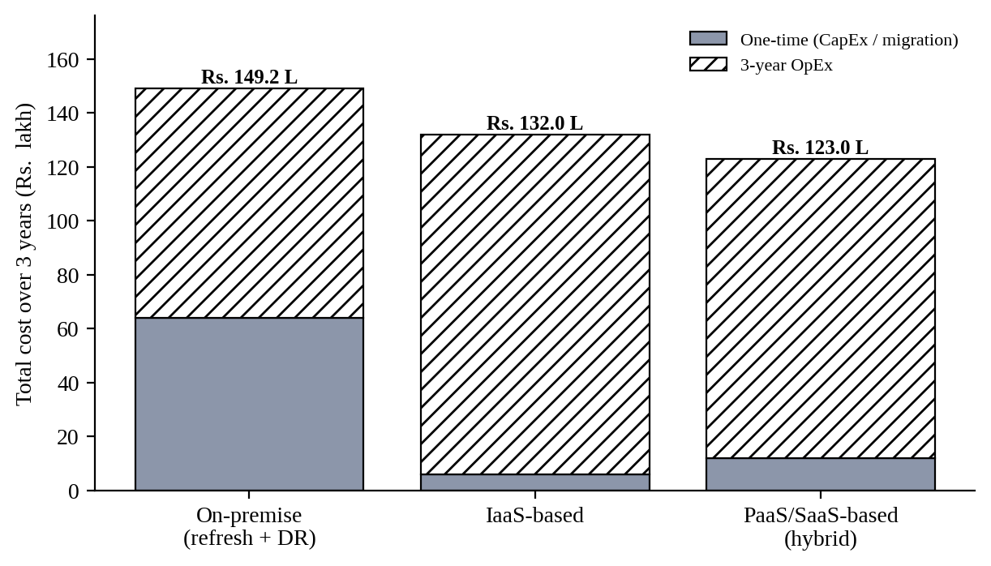
Figure 11: Three-year total cost of the three options (Rs. lakh)

10.3 Main risks and mitigation
Table 41: Risk register
Risk | Impact | Mitigation steps
Vendor lock-in | Hard and costly to change provider. | Use containers, standard SQL and REST; infrastructure-as-code; keep regular exports of data.
Data privacy | Student data leaks or legal non-compliance. | Encryption, role-based access, Indian region storage, data-processing agreement; follow the DPDP Act, 2023.
Downtime | Exams or admissions disrupted. | Multi-zone design, DR region, tested failover, SLAs, no major changes during exam weeks.
Skills gap | Staff cannot operate cloud services safely. | Training and certifications, partner support in the first year, runbooks, small pilot first.
Cost overrun | Unexpected bills. | Budgets and alerts, tagging, reserved capacity, monthly review.

10.4 Final recommendation and migration roadmap
Recommendation: adopt Option C – a hybrid PaaS/SaaS-first design, using IaaS only where full control is needed (Exam Portal, legacy SIS parts during transition). It has the lowest three-year cost, the best elasticity for the peaks in the scenario, built-in availability, and the lowest ongoing effort. The provider is chosen only after checking an Indian region, SLA, price and exit options – not because it is popular.
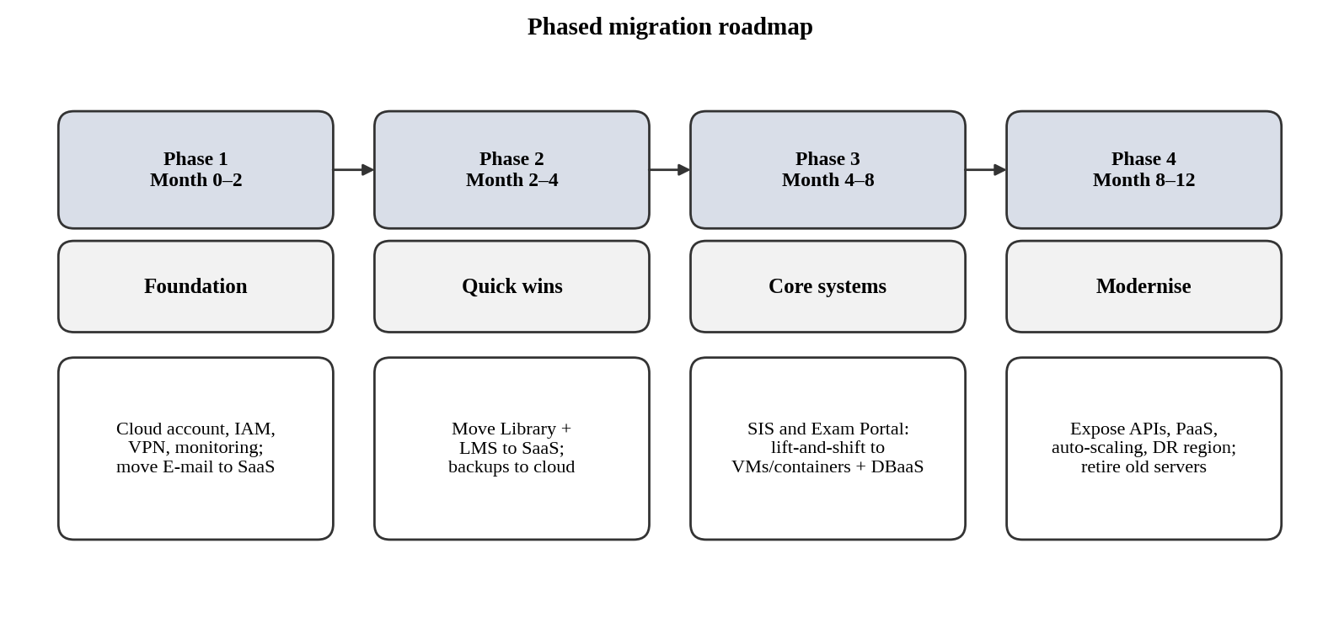
Figure 12: Phased migration roadmap
Why E-mail moves first: it is a standard service with no custom code, the migration is low risk, it gives immediate savings (free education tier and one fewer server pair), and it lets the team practise identity, security and support processes before moving the critical SIS and Exam Portal. Library and LMS follow because they are also standard. SIS and Exam Portal move later, once monitoring, backups and DR are tested, and they are modernised last because they are the most critical and complex.

TASK 11 – Re-evaluate and Adapt the Design (Day-4 Design Challenge)
Marks: 8
Table 42: Evaluator quick-check (requirement → section)
Task requirement | Answered in section
Impact analysis (2 marks) | Section 11.1
Evaluation of the original design (2 marks) | Section 11.2
Adaptation / redesign (2 marks) | Section 11.3
Evidence-based defence (2 marks) | Section 11.4

Decision in one line: REDESIGN (reusing the SaaS choices and the DBaaS/DRaaS decisions). The original design cannot reach 10× load and 99.9 % availability within budget without an API-first, multi-zone, container/serverless architecture.

11.1 Impact analysis
Table 43: What has changed and which assumptions are affected
Factor | Original assumption | Changed requirement
Users | 27,000 users on 4 campuses | Plus mobile users and 40 affiliated colleges
Load | Current peak = 1× | 10× current peak
Availability | Best effort; no DR | 99.9 % (about 8.76 hours downtime per year)
Access | Internal web access | Public mobile app and partner APIs
Cost | Fixed budget for one university | Limited operating budget shared across 41 institutions

Why web services and APIs become critical: the mobile app and the 40 colleges are external clients. They cannot use internal screens; they must call stable, secure, versioned APIs (student records, fee payment). The API gateway therefore becomes the front door of the whole system, handling authentication, throttling and monitoring.
Multi-tenancy: 40 colleges share one platform, so each college must see only its own students and data. This needs a tenant ID in every access token, row-level or schema-level data separation, separate encryption keys for sensitive data, per-tenant rate limits (to stop one college slowing others) and per-tenant audit logs. A single mistake could expose another college's records, so isolation is the main security risk.

11.2 Evaluation of the original design

(a) Capacity at 10× load
From Task 4, the current worst-case peak is 8.2 server-equivalents (8 servers at 95 % + 4 servers at 15 %). At 10× this becomes 82 server-equivalents, and at the 70 % host target the need is 82 ÷ 0.70 = about 117 host-equivalents. The original baseline of 4 private hosts plus VM-based cloud bursting cannot reach this quickly or cheaply.
Table 44: Can the original design carry the load?
Element | Assessment | Verdict
SaaS (LMS, e-mail, library) | Provider scales automatically. | Retain
PaaS for SIS | Scales, but monolith and single database limit it. | Modify
IaaS VMs for Exam Portal | VM start-up takes minutes; each VM carries an OS, so it is costly at 10×. | Redesign to containers
4-host private baseline | Cannot hold 117 host-equivalents. | Keep small; use cloud for peaks
Database | Single primary becomes a bottleneck. | Use DBaaS with replicas and cache

(b) Availability: 99.9 % target
99.9 % availability allows 0.001 × 8,760 h = 8.76 hours of downtime per year. Overall availability of components in series is the product of their availabilities. Redundant copies in parallel give 1 − (1 − A)ⁿ.
Table 45: Availability calculation (provider SLA figures are assumptions to be validated)
Design | Calculation | Result
Original: single zone — load balancer 99.99 %, app tier 99.5 %, database 99.5 % | 0.9999 × 0.995 × 0.995 = 0.98993 | 98.99 % → about 88 h/year. Fails.
Revised: multi-zone — LB 99.99 %, API gateway 99.99 %, app tier 2 zones (1 − 0.005² = 99.9975 %), DBaaS multi-zone 99.99 % | 0.9999 × 0.9999 × 0.999975 × 0.9999 = 0.99968 | 99.97 % → about 2.9 h/year. Meets 99.9 %.

Auto-scaling alone does not fix this, because a single-region, single-zone deployment still fails as a whole if the zone fails. Multi-zone placement is required, and the DR region protects against a region failure.

(c) Cost under the new load
Buying hardware for 117 host-equivalents at Rs. 8 L each would cost about Rs. 936 L (9.4 crore) before any DR, which is not acceptable for a limited budget, and it would sit idle most of the year. A cloud approach pays only for the peak hours (see 11.4).

(d) Would another service model or XaaS help?
- Serverless (FaaS) for spiky, short tasks (result lookup, receipts, notifications): scales to zero and costs nothing when idle.
- API management, CDN and IDaaS (identity) as services: central onboarding of 40 colleges with single sign-on.
- Payment gateway as a service: card data never touches the university's systems, which reduces security and compliance effort.

11.3 Adaptation or redesign
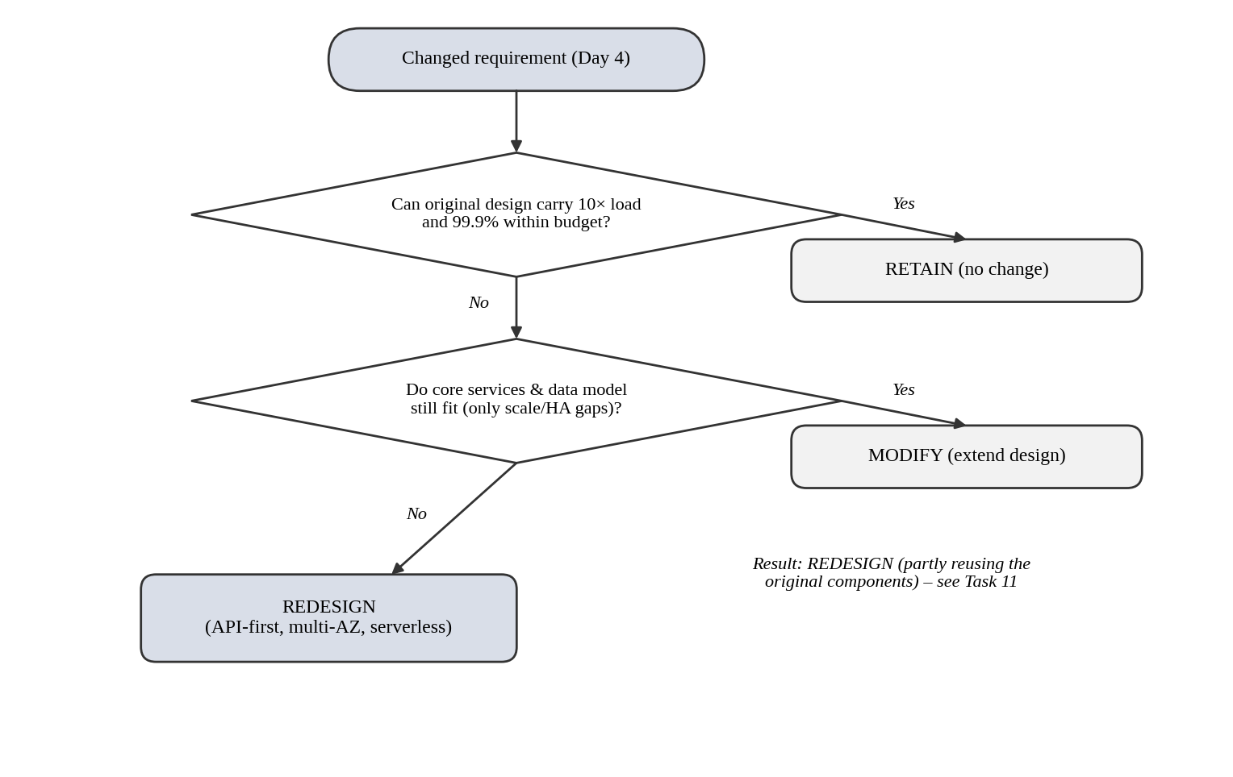
Figure 13: Decision flowchart: retain, modify or redesign
Decision: REDESIGN the application and data tier, but retain the good decisions: SaaS for e-mail, LMS and library; DBaaS and DRaaS; the hybrid model; and the security controls. The monolithic parts are moved to an API-first, container-based design.
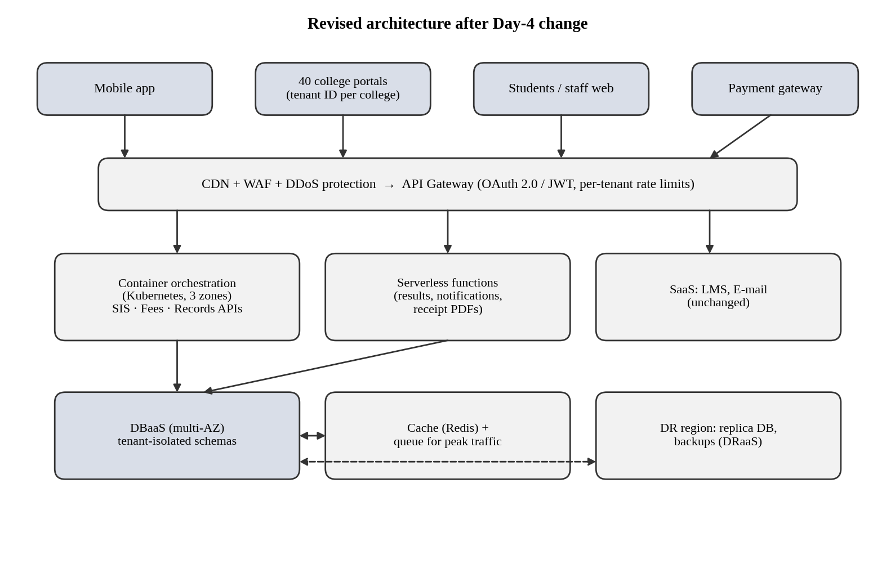
Figure 14: Revised architecture for 40 colleges, mobile app, 10× load and 99.9 % availability
Table 46: What changes in the service-model mix and virtualization approach
Area | Original design | Revised design
Entry point | Load balancer to web tier | CDN + WAF + API gateway with per-tenant throttling
SIS / fees / records | PaaS monolith on VMs | Containers on managed Kubernetes in 3 zones; services split by function
Spiky functions | Part of the monolith | Serverless functions (FaaS) that scale to zero
Exam Portal | IaaS VMs | Containers; VM only for the proctoring service
Database | DBaaS, single primary | DBaaS multi-zone + read replicas + cache + queues
Tenancy | Not needed | Tenant ID in tokens, tenant-isolated schemas, per-tenant keys
DR | Warm standby, region B | Same, with tested failover and cross-region backups
Virtualization | VMs on 4 private hosts + VM bursting | Mostly containers/serverless in public cloud; small private zone for sensitive data and the VPN link

11.4 Evidence-based defence

Capacity
The peak need of 117 host-equivalents is reduced by design: caching and the CDN serve about 60 % of read requests (static content, repeated result look-ups), so only 40 % reaches the application tier: 117 × 0.4 = 46.8, i.e. about 47 host-equivalents at peak. Peak periods (admissions, results, exams) are assumed to cover about 36 days a year, so the extra capacity runs for only 36 × 24 = 864 hours of the 8,760 hours in a year (about 10 %).

Cost comparison
Table 47: Yearly running cost of the revised design (Rs. lakh) – illustrative
Item | Original (Option C) | Revised
Base platform (PaaS, DBaaS, SaaS, storage, network) | 25.0 | 25.0
Staff | 12.0 | 12.0 + 6.0 (one DevOps engineer)
Burst compute: 47 host-equivalents × 864 h × Rs. 40/h | – | 16.2 (rounded to 16.0)
Always-on extra capacity for mobile and college traffic | – | 10.0
API gateway, CDN, WAF | – | 6.0
Multi-zone DBaaS upgrade | – | 6.0
Warm-standby DR upgrade and monitoring | – | 4.0 + 2.0
Total per year | 37.0 | 87.0

Table 48: Three-year view and cost sharing
Item | Value (Rs. lakh) | Remark
One-time cost: original 12 + redesign 8 | 20.0 | Refactoring, API work, tenant isolation
Running cost: 87 × 3 | 261.0 | Revised design
Three-year total (revised) | 281.0 | Compare: buying 117 hosts = about 936 before DR
Share per institution (41 = university + 40 colleges) | about 6.9 over 3 years (about 2.3 per year) | Chargeback based on measured usage

The revised design costs more than the original (Rs. 281 L vs Rs. 123 L over three years), but the original does not meet the new requirements. For the same new requirements, owning hardware would cost about Rs. 936 L before any DR. The cost is also shared across 41 institutions using measured service data.

Security and multi-tenancy
- Tenant ID in every JWT; the API refuses requests that do not match the tenant.
- Tenant-isolated schemas or row-level security; separate encryption keys for sensitive data; no shared admin accounts.
- Per-tenant throttling and quotas to prevent a noisy neighbour; audit logs per tenant; regular penetration tests.

Trade-offs
Table 49: Trade-offs of the redesign
Trade-off | Impact | Control
Vendor lock-in | Managed services and serverless increase dependency. | Use containers, open APIs and standard SQL; keep exit and backup plans.
Complexity | Kubernetes, gateways and serverless need new skills. | Managed Kubernetes, training, one DevOps hire, partner support.
Migration effort | Splitting the monolith takes time (about 3–4 extra months). | Strangler approach: move one API at a time while the old system keeps running.
Cost | Higher than the original design. | Reserved capacity, serverless, budgets and alerts, chargeback to colleges.

Final defence: the original design fails two requirements (98.99 % availability against 99.9 %, and no way to carry 10× load without very large purchases). The redesigned architecture reaches about 99.97 % on paper, handles load by caching and elasticity, isolates the 40 colleges, and costs about Rs. 281 L over three years instead of about Rs. 936 L for owned hardware. A load test and a failover test must confirm these estimates before go-live.

SUBMISSION CHECKLIST (student self-check)
Requirement | Status
All 11 tasks answered | Yes
Cloud concepts and comparisons explained | Yes
Virtualization calculations included | Yes
API examples and service models explained | Yes
Cloud architecture diagram included | Yes
Implementation and testing evidence provided | Partly – attach own screenshots (Task 9)
Three-year cost analysis and roadmap included | Yes
Day-4 design challenge completed | Yes
Figures and screenshots included | Partly – screenshots pending

  _______________  Student Signature | _______________  Faculty Signature | _______________  Program Director

